**Anti-Drink and Anti-Theft Mechanism**

**(ADAAT)**

**Urmil Shah**

CWID: …………

**Aniket Londhe**

CWID: 888251865

**Yeshwanth Bugata**

CWID:888241247

**Nasim Ghadyani Parsyari**

CWID: 893323782

California State University – Fullerton

**Rapid Prototyping for Internet of Things | EGCP-565│Dr. Kiran George**

Table of Contents

1. Abstract 3

2. Theory or Background. 3

3. Design Specification. 3

4. System Block Diagram.. 3

5. Flow Chart 3

6. Discussion of Performance evaluation/Testing. 3

7. Problems encountered. 3

8. Individual task Assignment 3

9. Conclusion. 3

10. Future work. 3

11. References 3

Appendices 3

# **1.** **Abstract**

The number of accidents in the United States due to driving under the influence of alcohol is on arise each year. Almost every hour, one person dies due to drunk driving crashes and a total of $44 billion damages. Alcohol is a substance that significantly reduces the driver function in terms of thinking, reasoning, and reaction time to an event. This paper explores the possibility of using Internet of Things (IoT) technology in the design of Anti-drink and Anti-Theft Mechanism (ADAAT) to detect the level of alcohol in the blood of driver before it allows the driver to operate the vehicle. The ADAAT device prevents drunk drivers by locking the steering wheel when the blood alcohol content exceeds 0.08%. Furthermore, the ADAAT device immediately notifies via phone application to choose either to call/text the emergency contacts set previously by the driver or booking an Uber.

The model created uses an Arduino UNO R3 and MQ-3 alcohol sensor to detect the blood alcohol content. The ADAAT device is attached to a steering wheel lock and when the MQ-3 alcohol sensor detects that the driver is sober, the system unlocks. The presented design can be produced as a product for every vehicle which can help to save the life of a drunk driver and other drivers on the road.

# **2.** **Theory or Background**

Internet of Things (IoT) and smart devices have a significant role on the future of technologies by connecting IP enabled devices via the internet to make them intelligent. IoT network is a bridge into different technologies to collect and share data by connecting systems, people and other applications. There are different types of chip architectures that can be used in IoT systems due to the requested application.

The presented project is focused on an application that can detect the alcohol level of drunk drivers. Driving a vehicle needs a full concentration of the driver thus, this design is introduced to reduce the number of accidents and make roads safer by not allowing intoxicated drivers to drive. This system locks the steering wheel when the blood alcohol content of the driver exceeds more than defined range.

Drunk driving has contributed over 300,000 car accidents and cost the country 132 billion dollars last year [x]. It is estimated that on average 1.41 Million people are arrested on DUI charges and approximately 30 lives are taken every day because of drunk driving. Majority of drunk drivers can be categories to ages between 25-34 [x].

# **3.** **Design Specification**

The ADAAT was built by specific hardware and software. The table below enlists the detail components.

|  |  |
| --- | --- |
| Hardware | Arduino UNO R3  MQ-3 Alcohol Sensor  Servo Motor  LCD  LED  Breadboard  Jumper cables |
| Software | Arduino IDE  MIT App Builder |

Table 1- ADAAT Hardware and Software Requirements

· **Arduino UNO R3**

This hardware component plays a crucial role in our project. The atmega328 microcontroller is the main part on this board. There are 14 digital I/O pins as inputs and output pins plus 6 analog inputs.

Figure 1: Arduino UNO R3

· **MQ-3 Alcohol Sensor**

MQ-3 is a breath analyzer which detects the alcohol content of drivers.Sensor provides an analog resistive output based on alcohol concentration.The drive circuit is very simple, all it needs is one resistor. A simple interface could be a 0-3.3V ADC.

Figure 2: MQ-3 Alcohol Sensor

· **Servo Motor**

Servo motor works on PWM (Pulse width modulation) principle, means its angle of rotation is controlled by the duration of applied pulse to its Control PIN. Basically servo motor is made up of DC motor which is controlled by a variable resistor (potentiometer) and some gears.All servo motors work directly with your +5V supply rails but we have to be careful on the amount of current the motor would consume, if you are planning to use more than two servo motors a proper servo shield should be designed.

**· Liquid Crystal Display (LCD)**

A 16x2 LCD is implemented in our project to illustrate the comments and the percentage of alcohol. If the driver’s blood alcohol level is less than the defined range, the lock mechanism will be opened after blowing to the alcohol sensor and the comment of “Driver is sober” will be shown on the LCD screen. In Initial state when the mechanism works the LED yellow is on. After blowing, if the driver be sober, the LED yellow goes off and LED green will turn on. On the other hand, If the driver was drunk and not allowed to drive, the mechanism will lock the steering will and the red LED will be on plus the comment of “Driver is drunk” on the LCD. The figure 3 below shows the LCD screen in both states. LCD works with +5V supply.

Figure 3: LCD screens

# **4.** **System Block Diagram**

The principle of the hardware chart is shown in the block diagram below, figure 4. The core function modules are Arduino UNO, MQ3 Sensor and Servo motor.

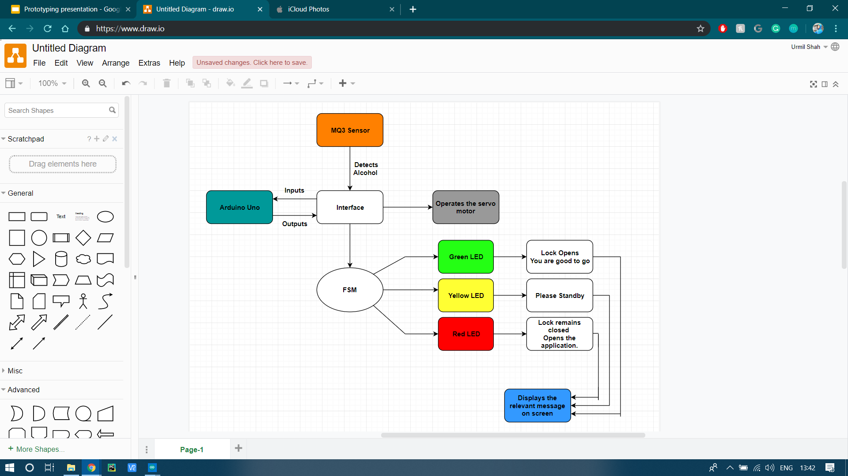

# **5.** **Flow Chart**

# **6.** **Discussion of Performance evaluation/Testing**

The presented product is used in a scenario that a drunk driver enters the car and wants to start driving. As the mechanism is settled down on the steering wheel before the driver left the car, the steering wheel is locked. So, the drunk driver should blow into the breathalyzer to open the lock. Two scenarios occur when MQ-3 sensor detects the breath and after compiling the operation in Arduino based on the blood alcohol level of driver, decides to open the lock or not. At this first stage the yellow LED is on to illustrate that the system is working.

If the person be sober, the mechanism will open, and the yellow LED will be off and Green LED is going to be on. The LCD screen will show the comment that the driver is sober. Furthermore, the steering wheel is unlocked, and the driver can start driving.

But if the drunk driver’s blood alcohol level is higher than the legal range for driving, which is defined in the written code, the mechanism will not open and the driver can not start driving. In this case, the red LED will be on and other LEDs are off. The LCD screen will show the two defined options in the designed application shown in figure 5. After recognition to prevent the drunk driver to drive, an application will pop up in the driver’s mobile phone which need to be install before and it shows two options. The driver can either call or text to each of the three defined emergency contacts that he defined previously in the application or by Choosing the Uber option opens the Uber application.

We have tried both cases and we were satisfied with the evaluation that we got.

# **7.** **Problems encountered**

In this project, we have faced three different challenges. First, the size of the whole package that wasn’t small enough to fix on the steering wheel. So, we decided to use another box to adhere to this problem.

Secondly, to do the authentication part for our project, we decided to use CO2 sensor. The driver blowing to the system could be recognized by two sensors. At first the CO2 sensor could define that the breath is from a human being not other devices as Air Conditioner and then the alcohol detector could start evaluating the alcohol value of driver blood. The result we obtained from programing part, was not accurate. The range of human being CO2 was the same as atmosphere CO2. Furthermore, we need more research to solve this issue.

Finally, we decided to use a fingerprint sensor to do the authentication. But we were not able to figure it out.

# **8.** **Individual task Assignment**

# **9.** **Conclusion**

The presented project is an effective product that prevent drunk drivers to operate the car. This intelligent system for vehicles works with an alcohol detector whose core is Arduino. Since the sensor targets the range of blood alcohol the driver, the designed application will pop up for drunk driver that is not eligible to drive. The drunk driver can choose either call/text defined emergency contacts or book an Uber. Also, the whole system has an advantage of protecting the car from theft and burglary. The future scope of this system is to use the CO2 sensor as an authentication step. This product provides the effective development in the automobile industry regarding to reduce the accidents cause due to alcohol.

# **10.** **Future work**

The presented product has a potential to save thousands of lives. Although the test shows the confidential functionality of our product, there are still some improvements that need to be added to it. To complete the two-authentication part, the final product will include a functioning C02 sensor and 2 layers of authentication.

There are several applications that our product can support their safety to make them safer. This product has applications in operating heavy machinery and long-haul trucking. Also, it has applications in law enforcement and insurance. The other application is tracking location in case of a little intoxication.

# **11.** **References**

# **Appendices**